
Cornell University ILR School
DigitalCommons@ILR

Student Works

ILR Collection

Spring 2014
What are the Top Factors That Drive Employee Retention and are There Demographic (Gender, Generation, Ethnicity, Geography, etc.) Differences in These Factors?
Marie Rose Muir
Cornell University
Lin Li
Cornell University
Follow this and additional works at: https://digitalcommons.ilr.cornell.edu/student Thank you for downloading an article from DigitalCommons@ILR. Support this valuable resource today!

This Article is brought to you for free and open access by the ILR Collection at DigitalCommons@ILR. It has been accepted for inclusion in Student Works by an authorized administrator of DigitalCommons@ILR. For more information, please contact catherwood-dig@cornell.edu.
If you have a disability and are having trouble accessing information on this website or need materials in an alternate format, contact web-accessibility@cornell.edu for assistance.

What are the Top Factors That Drive Employee Retention and are There Demographic (Gender, Generation, Ethnicity, Geography, etc.) Differences in These Factors?
Abstract
By reviewing literature, we identified a theoretical framework with two levels of turnover-collective and individual turnover. Then we probe into each level and elaborate on the top factors in each domain. Definition, effects on turnover and retention strategies are included for each factor.
Keywords
human resources, retention, employee retention, demographic factors in retention
Comments
Suggested Citation
Muir, M. R. (2014). What are the top factors that drive employee retention and are there demographic
(gender, generation, ethnicity, geography, etc.) differences in these factors? Retrieved [insert date] from Cornell University, ILR School site: http://digitalcommons.ilr.cornell.edu/student/59
Required Publisher Statement Copyright by the authors.

This article is available at DigitalCommons@ILR: https://digitalcommons.ilr.cornell.edu/student/59
Marie Rose Muir & Lin Li Mar 7, 2014

EXECUTIVE SUMMARY

Research Question
What are the top factors that drive employee retention and are there demographic (gender, generation, ethnicity, geography, etc.) differences in these factors, or are they consistent across all demographic groups?

Overview
By reviewing literature, we identified a theoretical framework with two levels of turnover-collective and individual turnover. Then we probe into each level and elaborate on the top factors in each domain. Definition, effects on turnover and retention strategies are included for each factor.
Retention vs. Turnover-two sides of one coin? Upon speaking with retention expert John Hausknecht at ILR school, by definition, retention can be viewed as logical inverse of turnover as the behavior to stay rather than leave the organization. Retention and turnover metrics (Appendices A/B), however, are compliments rather than reverse. When benchmarking and analyzing metrics, human resources managers should keep in mind of the difference.^{1,2}
Collective & Individual Turnover Collective turnover encompasses turnover at any level higher than the individual, including group, unit and organization turnover. Rather than an aggregate of individual turnover, collective turnover can be linked with variables that do not exist at individual level (e.g., group size, firm performance). Individual-level predictors of turnover can change, or even reverse at collective level. ⁴ A framework explains collective turnover is attached as Appendix C.

Retention Factors for Collective Turnover
Among the antecedents of collective turnover, human systems/practices was found to have strongest correlation with collective turnover. Within human systems/practices, internal mobility, high-commitment HR system and staffing selectivity were the most significant factors in place. ⁵ Other retention factors include average age, tenure, female percentage, participation-enhancing work design, etc (Appendix D).

Internal Mobility
Internal mobility is defined as the extent to which an organization utilizes “a policy of staffing from within the organization”.⁵ Although internal mobility policies may reduce turnover generally, actual promotion rates prove to have stronger effect on reducing turnover than perceived internal mobility. To enhance internal mobility, HR professionals should not solely rely on advertising of internal job vacancies. Talent management systems can match current employees to open roles across the organization based on skills, aspirations and performance, thus enabling the employer to proactively offer new roles to appropriate employees. ⁷ However, given the substantial cost and scale, internal mobility should be viewed as long-term solutions rather than short-term remedies.⁵ High-commitment HR system
High-commitment HR system is defined as “HR systems designed to shape desired employee behaviors and attitudes by forming psychological links between organizational and employee goals”. ⁵ Researches have shown that employees’ commitment to the organization derives from their perceptions of the employers’ commitment to and support of them.⁸ Implementing high-commitment HR system requires more than a single practice. An organization must take the steps necessary to develop the perception of involvement among low and high level employees. Also, an organization should also build a mo re inclusive and less bureaucratic culture, since the process is likely to be lengthy and even costly until the appropriate culture is achieved.⁹

Staffing selectivity
Staffing selectivity is defined as the extent to which the organization hires a small proportion of applicants. When designing staffing strategy, HR professionals should be mindful to the fact that the sophistication of selection system themselves shared only weak relationships with collective turnover. Faced with turnover problems and limited resources, managers should increase the quality and size of applicant pools rather than improve their selection instruments. ⁵

Retention Factors for Individual Turnover Demographic Differences
Recent studies find that women and racial minorities have lower retention rates than white men⁶. Prior to analyzing the demographic disparities in retention, however, one must first understand the relationship between employee tenure and job retention. One of the most impactful influences on retention is position tenure: across all demographics, the more time one spends in a company the lower the turnover is⁶. For this reason, retention efforts should be aimed towards newer employees across all demographic spreads. However, a greater percentage of minorities and women hold low-tenure positions meaning turnover is higher for their overall populations⁶. To view these trends graphically please refer to Appendix C⁶. Lower retention for minorities and women in these lower tenured positions are often related to poor socialization on the part of the company e.g. poor mentoring and receiving less meaningful assignments⁶.
Gender: Overall, retention is lower for women than for men⁶. This arises for a variety of reasons, such as: low association as ‘in-group’ members in male-majority work settings, domestic responsibilities/ obligations that are poorly accommodated for by the firm, lower pay, sparser developmental opportunities, more career obstacles⁶. Race: Retention is also lower for minorities than it is for whites⁶. While improved diversity recruiting efforts may bring more diversity into an organization, organizations have trouble retaining minorities it does not meet the demographic expectations of entry minorities. In determining their ‘fit’, i.e. the process of socialization, with an organization, “minorities may interpret numerical rarity of executives of color as an indicator of barriers to advancement, motivating them to seek opportunities elsewhere” ⁶. The order of difficulty in socialization by race is: African American, Hispanic American, Asian American, White. As double minorities, female minorities experience the greatest challenges to socialization.
Similarity attraction thesis- members of a particular demographic subgroup take flight when demographically dissimilar members increasingly populate the workplace⁶. For example, in a recent study, there was a drop in retention among men in an organization as the number of females increased Appendix E⁶.

Job-Related Differences
Job Level: It is important to analyze retention factors for unique job levels because each will value different features of the company and will hold a different psychological contract with the organization. Research demonstrates that hourly workers are more likely to cite transactional retention factors whereas workers at higher job levels are more likely to cite relational retention factors³. Please see Appendix F³ for a graphical analysis of reported reasons for retention by job level.
Job Performance: It is important to understand how companies can best retain high performers because “High performers are most likely to possess the knowledge, skills and experience necessary to contribute to the overall success of the organization” ³. High performers are more likely to stay due to organization prestige and advancement opportunities whereas low performers place higher value on extrinsic rewards; these results can be in greater graphical detail in Appendix G³. An explanation of the definitions for each of these retention factors can be viewed in Appendix H³.
(no 25 and 26)

Appendix A

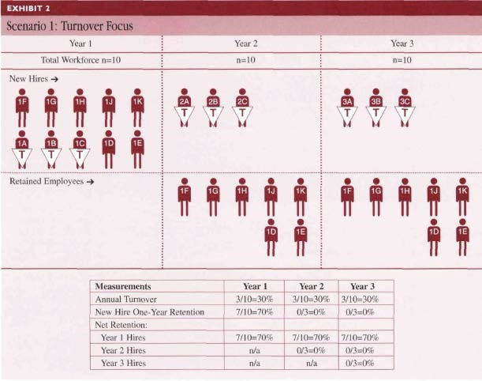

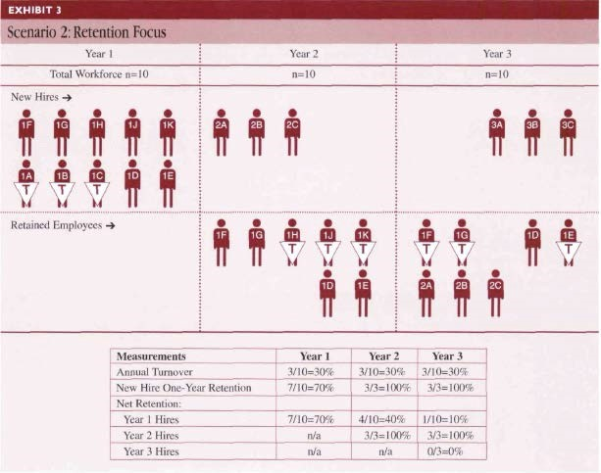

Appendix C

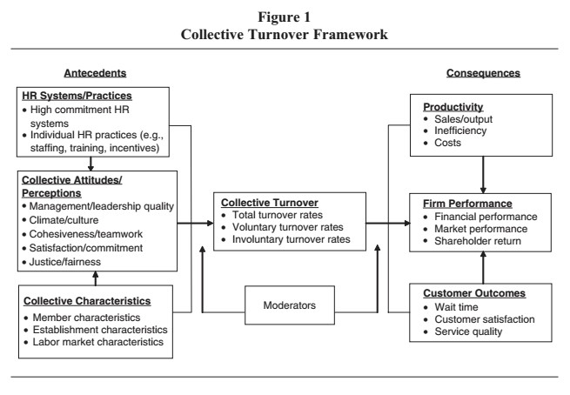

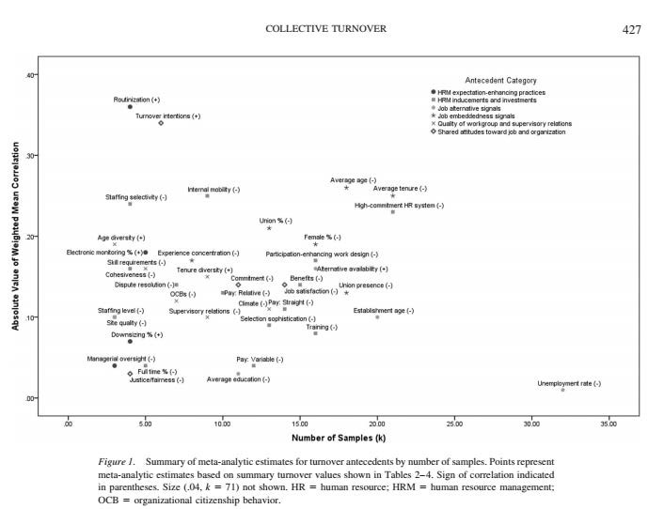

Appendix E

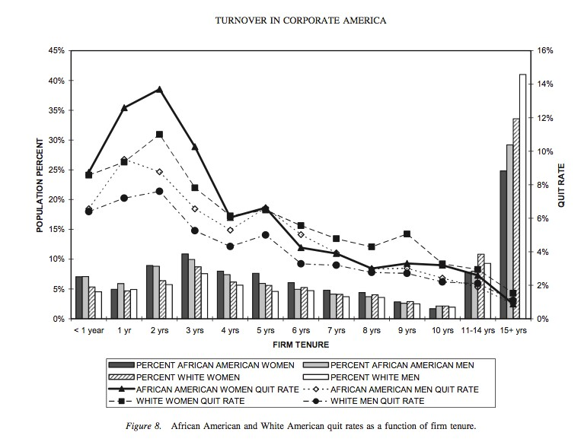

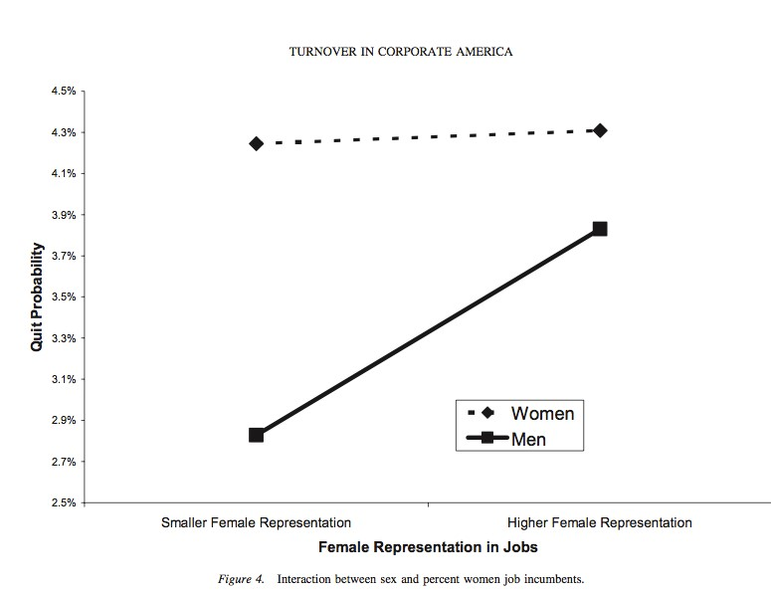

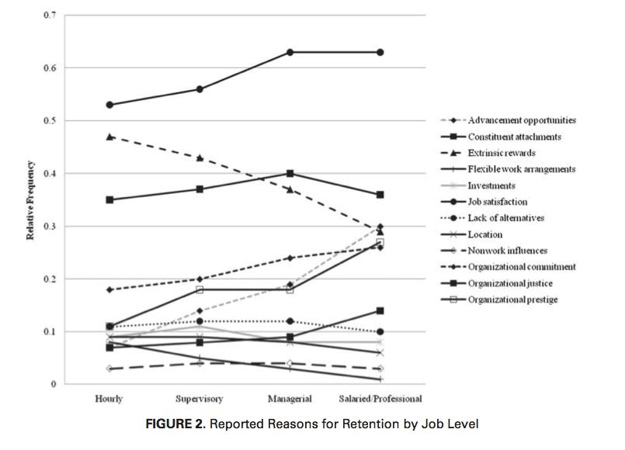

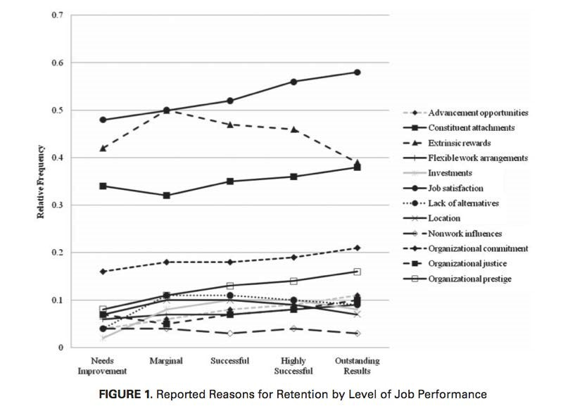

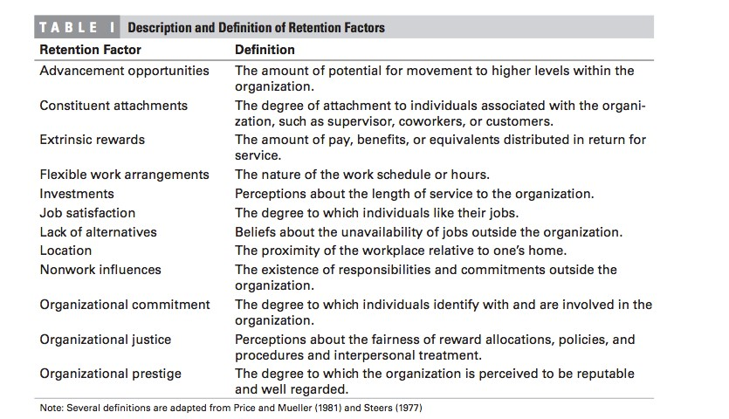

Works Cited

- (2012). Retention: How do I calculate retention? Is retention related to turnover? SHRM
- J, D. W., & Arora, S. (2004). Measuring retention rather than turnover: A different and complementary HR calculus. HR.Human Resource Planning, 27(3), 6-9.
- Hausknecht, J. P., Rodda, J., & Howard, M. J. (2009). Targeted employee retention: Performance-based and job-related differences in reported reasons for staying. Human Resource Management, 48(2), 269-288.
- Hausknecht, J. P., & Trevor, C. O. (2011). Collective turnover at the group, unit, and organizational levels:
Evidence, issues, and implications. Journal of Management, 37(1), 352-388.
- Heavey, A. L., Holwerda, J. A., & Hausknecht, J. P. (2013). Causes and consequences of collective turnover: A meta-analytic review. Journal of Applied Psychology, 98(3)
- Hom, P. W., Roberson, L., & Ellis, A. D. (2008). Challenging Conventional Wisdom About Who Quits: Revelations From Corporate America. Journal Of Applied Psychology, 93(1), 1-34.
- Snell, A. (2009). Tackling the challenges of employee engagement. Strategic HR Review, 8(2), 37-38.
- Whitener, E. M. (2001). Do "high commitment" human resource practices affect employee commitment? A cross-level analysis using hierarchical linear modeling. Journal of Management, 27(5), 515-535.
- Vandenberg, R. J., Richardson, H. A., & Eastman, L. J. (1999). The impact of high involvement work processes on organizational effectiveness: A second-order latent variable approach. Group & Organization Management, 24(3), 300-339.

Further Reading
- SHRM Foundation’s Effective Practice Guidelines Series: Retaining Talent-A Guideline To Analyzing And Managing Employee Turnover http://www.shrm.org/about/foundation/research/documents/retaining%20talent-%20final.pdf
- Cole, C. R., & McCullough, K. A. (2012). THE INSURANCE INDUSTRY'S TALENT GAP AND WHERE WE GO FROM HERE. Risk Management and Insurance Review, 15(1), 107-116.
Retrieved from http://search.proquest.com/docview/1314776071?accountid=10267
Abstract: There is concern among insurers and related firms in the US and abroad that there will be a shortage of skilled insurance professionals in the next few years as current workers retire. Though there have been discussions among insurers, organizations, and academics as to how to address this issue, until recently, each group has been primarily working in isolation. The Insurance Education & Career Summit, which took place in Sep 2011, brought together 110 individuals across these groups for the purpose of creating a unified strategy to both attract and retain skilled workers to the insurance industry and work to create the next generation of insurance executives. This article provides a brief background on the talent gap issue. We also discuss its potential impact on the insurance industry. Finally, we summarize the main obstacles identified by Summit participants to both attracting and retaining skilled workers as well as the strategies developed to overcome these obstacles.
- Allen, D. G., Bryant, P. C., & Vardaman, J. M. (2010). Retaining talent: Replacing misconceptions with evidence-based strategies. The Academy of Management Perspectives, 24(2), 48.
Retrieved from http://search.proquest.com/docview/611022354?accountid=10267
Abstract: Despite extensive scholarly research and organizational interest in employee turnover, there remains a gap between science and practice in this area. This article bridges this gap and replaces several misconceptions about turnover with guidelines for evidence-based retention management strategies focused on shared understanding of turnover, knowledge of cause-and-effect relationships, and the ability to adapt this knowledge and apply it to disparate contexts. We provide new tools such as an illustration of the relative strength of turnover predictors, a summary of evidence-based HR strategies for managing turnover, and a new framework for implementing evidence-based retention strategies. We conclude with a research agenda to build on this evidence-based understanding.
- Kwon, W. J. (2014). Human capital risk and talent management issues in the insurance market: Public policy, industry and collegiate education perspectives. Geneva Papers on Risk & Insurance, 39(1), 173-196. doi:
http://dx.doi.org/10.1057/gpp.2013.11
Abstract: The human capital attraction and retention challenges in the insurance industry intensify due to a combining effect of demographic, social, economic and market-specific factors. In addition, there is human capital obsolescence risk. The study findings indicate that: the financial services occupation group requires high competency in cognitive abilities, social perspectives, management knowledge and communication skills, but not much in technical, physical/sensory or engineering skills; the insurance industry and most insurance companies have not attained a high reputation; and insurance is not a widely recognised profession by the public and many college students. Based on our macro- and micro-spective investigation of the industry and university education, we recommend: more public relations activities, closer work with local universities and their faculties for adoption of the field as a major; better talent recruitment, training and retention programmes; and preparedness for talent morbidity across financial services sectors and countries.

